

**INFORMATION AND COMMUNICATION TECHNOLOGY DEPARTMENT**

**POLITEKNIK SEBERANG PERAI**

PROBLEM BASED TASK

**DFP5043**

**SOFTWARE REQUIREMENT AND DESIGN**

**JUNE 2020**

**GROUP MEMBERS:**

|  |  |  |
| --- | --- | --- |
| **NO.** | **NAME** | **REGISTRATION NUMBER** |
| **1.** | **NUR SYAHIRAH BINTI MOHD TARMIZI** | **10DDT18F1064** |
| **2.** | **SITI HAZWANI BINTI ABDUL SHUKOR** | **10DDT18F1061** |
| **3.** | **MUHAMMAD ALIF BIN MOHD NASIR** | **10DDT18F1055** |
| **4.** |  |  |
| **5.** |  |  |
| **6.** |  |  |

Learning Outcome

CLO2: Constructs appropriate project planning and tools for project scheduling, software requirements, software design and software construction. (P4, A4, PLO2, PLO5)

CLO 3: Solve issues related to project development using a variety of requirements techniques. (A4, C4, PLO4, PLO1)

Instruction

This is team based work (6-7 students per group). You may use any relevant report templates as your references.

Due date is on Friday, 27 November 2020 before 5.00 pm.

**Question**

You are required to build a full Software Requirement Specification (SRS) document based on your group chosen title. You may choose any relevant project development with any requirement basis as your project case study. Your document should include all the contents below

**Chapter 1: Introduction. (CLO2P)- [15 MARKS]**

1.1 Purpose – 5 marks (P2)

Explain the purpose of developing SRS document – must related with your group project title

1.2 Scope – 5 marks (P2)

Explain the system scope and user scope document – must related with your group project.

1.3 Overview – 5 marks (P2)

Brief explanation about your group project

**Chapter 2: Specific Requirement.(CLO2P)- [50 MARKS]**

2.1 Construct System functions (P4)

* + 1. Flow Chart – 10 marks

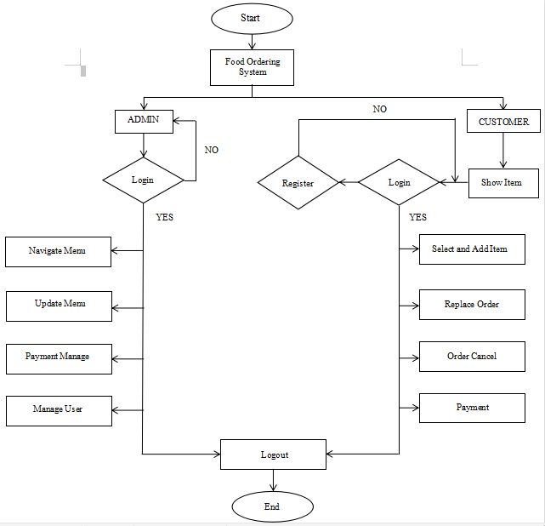

Figure 2.1.1: Flowchart for Food Ordering System

* + 1. Use case Diagram – 10 marks

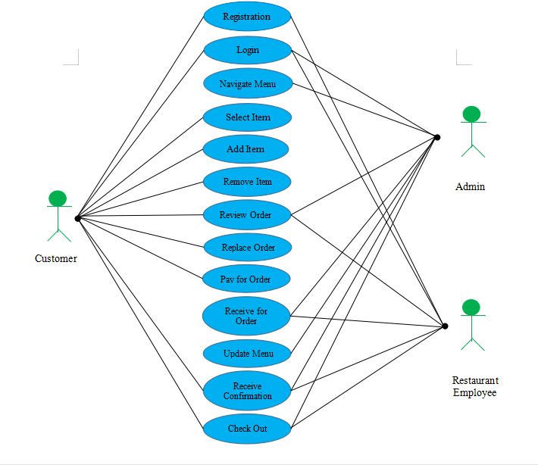

Figure 2.1.2 : Use case Diagram for Food Ordering System

* + 1. Sequence Diagram – 10 marks

Kitchen

Bill

Order

Menu Card

Customer

read()

Place order()

Order sent()

Food served()

Serve()

Calc_Bill()

Bill()

Bill()

Bill()

Pay_Bill()

* 1. Display your Performance Requirement (hardware and software) (P3)
     1. Hardware requirement – 5 marks

**Vivo Y11**

* 4G / LTE
* Octa-core (2x1.95 GHz Cortex-A53 + 6x1.45 GHz Cortex A53)
* 3GB RAM and 32 GB internal storage
* Android 9.0 and 5000 mAh
* Rear Camera, 13 MP + 2 MP depth sensor

**Toshiba Intel Core i5 Dynabook Satellite B452/H**

* Storage: 360 GB HDD
* Processor: Intel® Celeron® Cpu 1000M @ 1.80GHz

2.2.2 Software requirement – 5 marks

**Microsoft Visual Studio**

* Microsoft Visual Studio is an integrated development environment (IDE) from Microsoft. It is used to develop computer programs, as well as websites, websites, web apps, web services and mobile apps. Visual Studio uses Microsoft software development platforms such as Windows API, Windows Forms, Windows Presentation Foundation, Windows Store and Microsoft Silverlight. It can produce both native code and managed code.

**Microsoft Access**

* Microsoft Access is database management system (DBMS) from Microsoft that combines the relational Microsoft Jet Database Engine with a graphical user interface and software-development tools.

2.3 Construct Logical Database Requirement (P4)

2.3.1 Entity Relationship Diagram – 5 marks

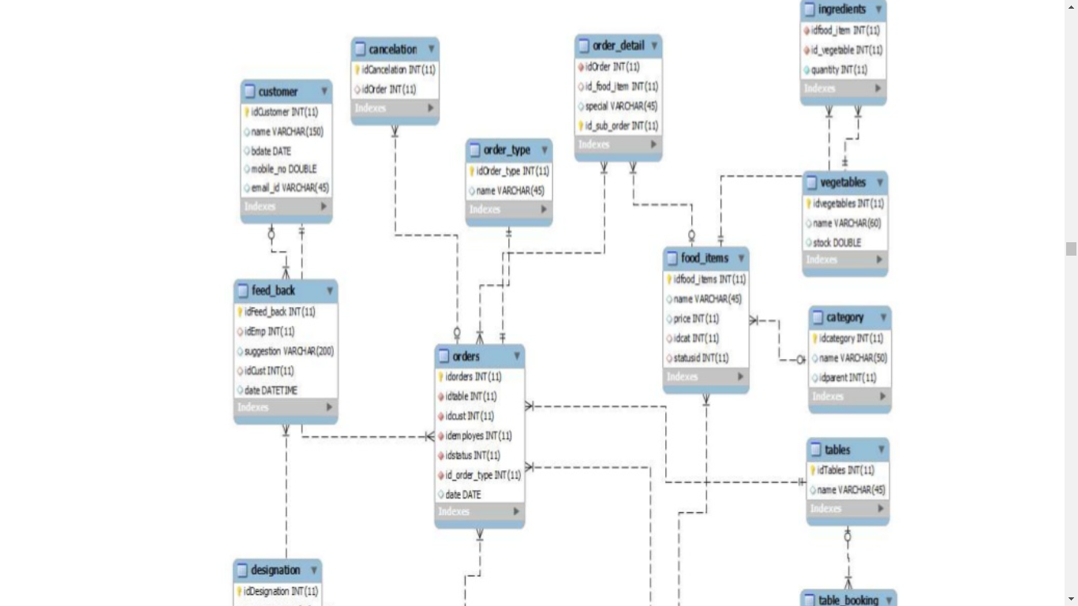 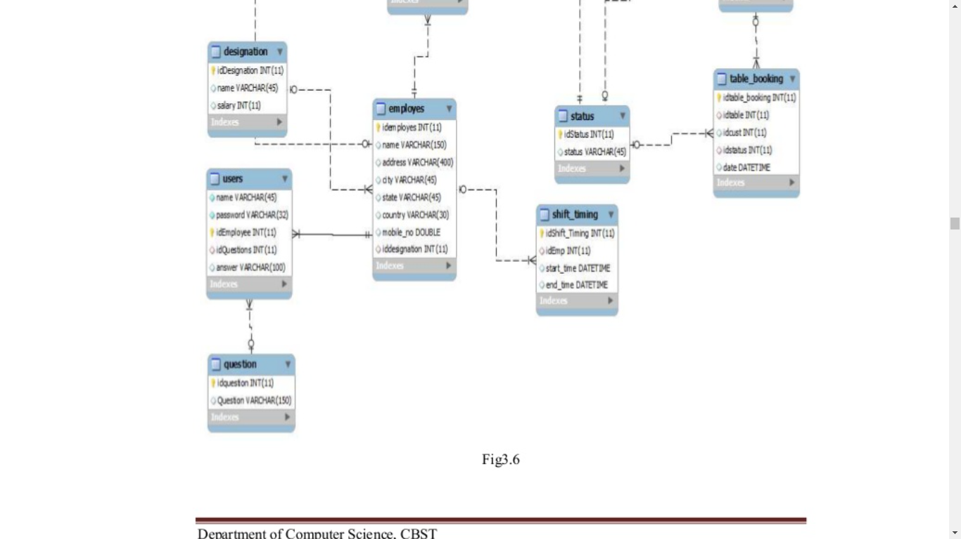

2.3.2 Data Dictionary – 5 marks

1. Users:

|  |  |  |
| --- | --- | --- |
| **Field Name** | **Data Type** | **Size** |
| Name | VARCHAR | 20 |
| Password | VARCHAR | 32 |
| idEmployee | INT |  |
| idQuestion | INT |  |
| Answer | VARCHAR | 100 |

1. Cancelation:

|  |  |  |
| --- | --- | --- |
| **Field Name** | **Data Type** | **Size** |
| idCancelation | INT |  |
| idOrder | INT |  |

1. Category:

|  |  |  |
| --- | --- | --- |
| **Field Name** | **Data Type** | **Size** |
| idCategory | INT |  |
| Name | VARCHAR | 32 |
| idParent | INT |  |

1. Customer:

|  |  |  |
| --- | --- | --- |
| **Field Name** | **Data Type** | **Size** |
| idCustomer | INT |  |
| Name | VARCHAR | 150 |
| Bdate | Date |  |
| Mobile_no | DOUBLE |  |
| Email_id | VARCHAR | 45 |

1. Designation:

|  |  |  |
| --- | --- | --- |
| **Field Name** | **Data Type** | **Size** |
| idDesignation | INT |  |
| Name | VARCHAR | 45 |
| Salary | INT |  |

1. Employee:

|  |  |  |
| --- | --- | --- |
| **Field Name** | **Data Type** | **Size** |
| idEmployee | INT |  |
| Name | VARCHAR | 150 |
| Address | VARCHAR | 400 |
| City | VARCHAR | 30 |
| State | VARCHAR | 30 |
| Mobile_no | DOUBLE |  |
| idDesignation | INT |  |

1. Feed_Back:

|  |  |  |
| --- | --- | --- |
| **Field Name** | **Data Type** | **Size** |
| idFeed_Back | INT |  |
| Suggestion | VARCHAR | 200 |
| idEmployee | INT |  |
| idCustomer | INT |  |

1. Food Item:

|  |  |  |
| --- | --- | --- |
| **Field Name** | **Data Type** | **Size** |
| idFood_item | INT |  |
| Name | VARCHAR | 45 |
| Price | INT |  |
| idCategory | INT |  |

1. Ingredients:

|  |  |  |
| --- | --- | --- |
| **Field Name** | **Data Type** | **Size** |
| idFood_Item | INT |  |
| idVegetable | INT |  |
| Quantity | INT |  |

1. Order Type:

|  |  |  |
| --- | --- | --- |
| **Field Name** | **Data Type** | **Size** |
| idOrder_type | INT |  |
| Name | VARCHAR | 45 |

1. Order:

|  |  |  |
| --- | --- | --- |
| **Field Name** | **Data Type** | **Size** |
| idOrder | INT |  |
| idTable | INT |  |
| idCustomer | INT |  |
| idEmployee | INT |  |
| idStatus | INT |  |
| idOrder_type | INT |  |
| Date | Date |  |

1. Order Details:

|  |  |  |
| --- | --- | --- |
| **Field Name** | **Data Type** | **Size** |
| idSub_Order | INT |  |
| idOrder | INT |  |
| idFood_item | INT |  |
| Special | VARCHAR | 45 |

1. Shift Timing:

|  |  |  |
| --- | --- | --- |
| **Field Name** | **Data Type** | **Size** |
| idShift_Time | INT |  |
| idEmployee | INT |  |
| Start_Time | DateTime |  |
| End_Time | DateTime |  |

1. Status:

|  |  |  |
| --- | --- | --- |
| **Field Name** | **Data Type** | **Size** |
| idStatus | INT |  |
| Status | VARCHAR | 45 |

1. Tables:

|  |  |  |
| --- | --- | --- |
| **Field Name** | **Data Type** | **Size** |
| idTable | INT |  |
| Name | VARCHAR | 45 |

1. Table Booking

|  |  |  |
| --- | --- | --- |
| **Field Name** | **Data Type** | **Size** |
| idTable_booking | INT |  |
| idTable | INT |  |
| idCustomer | INT |  |
| idStatus | INT |  |
| Date | Date |  |

1. Questions:

|  |  |  |
| --- | --- | --- |
| **Field Name** | **Data Type** | **Size** |
| idQuestion | INT |  |
| Question | VARCHAR | 100 |

1. Vegetables:

|  |  |  |
| --- | --- | --- |
| **Field Name** | **Data Type** | **Size** |
| IdVegetable | INT |  |
| Name | VARCHAR | 45 |
| Stock | DOUBLE |  |

**Chapter 3: Supporting Information. (CLO3C)- [30 MARKS]**

* 1. Illustrate Project planning (gantt chart) and task delegation (table) – 10 marks (C4)
  2. Risk Management 10 marks (C4)

Explain about risk that might occur and how your handle it

* 1. Teamwork and leadership 10 marks (C4)

Explain about you teamwork

**Chapter 4: References and Appendix. (CLO3C)- [5 MARKS]** (C4)

List all your references and appendix – 5 marks

Rubrik Chapter 1: Introduction. (CLO2P)- [15 MARKS]

|  |  |  |  |  |  |  |
| --- | --- | --- | --- | --- | --- | --- |
| Title | 5 | 4 | 3 | 2 | 1 | 0 |
| Purpose (P2) | Always clearly explains the purpose of the project to be undertaken | Clearly explains the project to be undertaken most of the time | Sometimes clearly explains the project to be undertaken | Occasionally explains the project to be undertaken | Unclear and incomplete understanding of the project to be taken | Vague about the project to be undertaken |
| Scope (P2) | Always clearly clarify system scope and user scope | Clearly clarify system scope and user scope most of the time | Most of the required  system scope and user scope are included | Few of the required  system scope and user scope are included | No clear clarification between system scope and user scope | Do not clarify user between system scope and user scope |
| Overview (P2) | explanation of the project significance | Very Clear explanation of the project significance | Clear explanations of project significance | Less clear about project significance | State very little about the project significance | Do Not state the project significance |

Rubrik Chapter 2: Specific Requirement.(CLO2P)- [50 MARKS]

**2.1 system functions** (P4)

|  |  |  |  |  |  |  |
| --- | --- | --- | --- | --- | --- | --- |
|  | 5 | 4 | 3 | 2 | 1 | 0 |
| **Flow chart** | The structure is appropriate for the project | The structure is not so appropriate for the project | The structure is relevant but not related with the project | The structure is there but not relevant and not related with the project | Its copy paste from the internet | No flowchart |
|  | Each element was labelled and correct symbol is used | 1-2 element was not labelled and 1-2 symbol is wrong | More than 2 element was not labelled and more than 2 symbol is wrong | The element and symbol used were totally wrong | Its copy paste from the internet | No flowchart |
| **Use case diagram** | The structure is appropriate for the project | The structure is not so appropriate for the project | The structure is relevant but not related with the project | The structure is there but not relevant and not related with the project | Its copy paste from the internet | No use case diagram |
|  | Each element was labelled and correct symbol is used | 1-2 element was not labelled and 1-2 symbol is wrong | More than 2 element was not labelled and more than 2 symbol is wrong | The element and symbol used were totally wrong | Its copy paste from the internet | No use case diagram |
| **Sequence diagram** | The structure is appropriate for the project | The structure is not so appropriate for the project | The structure is relevant but not related with the project | The structure is there but not relevant and not related with the project | Its copy paste from the internet | No sequence diagram |
|  | Each element was labelled and correct symbol is used | 1-2 element was not labelled and 1-2 symbol is wrong | More than 2 element was not labelled and more than 2 symbol is wrong | The element and symbol used were totally wrong | Its copy paste from the internet | No sequence diagram |

* 1. Performance Requirement (hardware and software) (P3)

|  |  |  |  |  |  |  |
| --- | --- | --- | --- | --- | --- | --- |
|  | 5 | 4 | 3 | 2 | 1 | 0 |
| Hardware requirement | List 5 or more requirement | List only 4 requirement | List only 3 requirement | List only 2 requirement | List only 1 requirement | No hardware requirement |
| Software requirement | List 5 or more requirement | List only 4 requirement | List only 3 requirement | List only 2 requirement | List only 1 requirement | No software requirement |

* 1. Logical Database Requirement (P4)

|  |  |  |  |  |  |  |
| --- | --- | --- | --- | --- | --- | --- |
|  | 5 | 4 | 3 | 2 | 1 | 0 |
| Entity Relationship Diagram | The structure is appropriate for the project | The structure is not so appropriate for the project | The structure is relevant but not related with the project | The structure is there but not relevant and not related with the project | Its copy paste from the internet | No entity relationship diagram |
| Data Dictionary | The structure is appropriate for the project | The structure is not so appropriate for the project | The structure is relevant but not related with the project | The structure is there but not relevant and not related with the project | Its copy paste from the internet | No software requirement |

**Chapter 3: Supporting Information. (CLO3P)- [30 MARKS]**

* 1. Project planning (gantt chart) and task delegation (table) – 10 marks (C4)

|  |  |  |  |  |  |  |
| --- | --- | --- | --- | --- | --- | --- |
|  | 5 | 4 | 3 | 2 | 1 | 0 |
| Gantt Chart | The structure is appropriate for the project | The structure is not so appropriate for the project | The structure is relevant but not related with the project | The structure is there but not relevant and not related with the project | Its copy paste from the internet | No gantt chart |
| Task delegation | List all group members name and their full task | Task were given but not mentioning task completely | Task delegation in not fair | Task delegation is not suitable for the group | Task delegation not completed | No task delegation |

* 1. Risk Management 10 marks (C4)

Explain about risk that might occur and how your handle it

1 mark will be given for each relevant risk and 1 mark for how it can be handle. Max 10 marks

* 1. Teamwork and leadership 10 marks (C4)

Explain about you teamwork

2 marks will be given for each explanation/ description about either teamwork or leadership. Max 10 marks

**Chapter 4: References and Appendix. (CLO3C)- [5 MARKS]** (C4)

List all your references and appendix – 5 marks

|  |  |  |  |  |  |  |
| --- | --- | --- | --- | --- | --- | --- |
|  | 5 | 4 | 3 | 2 | 1 | 0 |
| References | List 5 and more references | List 4 references | List 3 references | List 2 references | List only one reference | No references |